“Наследование и иерархия”

Иерархия 1

Листинг класса Person

using System;

namespace Inheritance.Hierarchy01

{

class Person

{

private int age;

private string name;

public Person(int age, string name)

{

this.age = age;

this.name = name;

}

public void SetName(string name)

{

this.name = name;

}

public void SetAge(int age)

{

this.age = age;

}

public virtual void Print()

{

Console.WriteLine($"Имя- {name}, Возраст- {age}");

}

public override string ToString()

{

return $"Имя-- {name}, Возраст-- {age}";

}

}

}

Листинг класса Person

using System;

namespace Inheritance.Hierarchy01

{

class Student : Person

{

private int course;

private string group;

public Student(string name, int age, int course, string group)

: base(age, name)

{

this.course = course;

this.group = group;

}

public void NextCourse(int course)

{

this.course = course;

}

public override string ToString()

{

return $"{base.ToString()}, Группа-- {group}, Курс-- {course}";

}

public override void Print()

{

Console.WriteLine(ToString());

}

}

}

Листинг класса Teacher

using System;

namespace Inheritance.Hierarchy01

{

class Teacher : Person

{

private string disciplines;

public Teacher(string name, int age, string disciplines)

: base(age, name)

{

this.disciplines = disciplines;

}

public void AddDiscipline(string disciplines)

{

this.disciplines = disciplines;

}

public void RemoveDiscipline()

{

disciplines = null;

}

public override string ToString()

{

return $"{base.ToString()}, Дисциплин-- {disciplines}";

}

public override void Print()

{

Console.WriteLine(ToString());

}

}

}

Иерархия 2

Листинг класса Content

using System;

namespace Inheritance.Hierarchy02

{

abstract class Content

{

public int ID { get; set; }

public string Name { get; set; }

public DateTime UploadDate { get; set; }

public Content(int id, string name, DateTime uploadDate)

{

ID = id;

Name = name;

UploadDate = uploadDate;

}

public override string ToString()

{

return $"Номер-- {ID}, Название-- {Name}, Дата-- {UploadDate}";

}

}

}

Листингл касса Photo

using System;

namespace Inheritance.Hierarchy02

{

class Photo : Content

{

public int WhoIsOnPicture { get; set; }

public Photo(int whoIsOnPicture, int id, string name, DateTime uploadDate)

: base(id, name, uploadDate)

{

whoIsOnPicture = WhoIsOnPicture;

}

public override string ToString()

{

return $"{base.ToString()}, На фото-- {WhoIsOnPicture}";

}

}

}

Листингл касса Video

using System;

namespace Inheritance.Hierarchy02

{

class Video : Content

{

public int Time { get; set; }

public Video(int time, int id, string name, DateTime uploadDate)

: base(id, name, uploadDate)

{

Time = time;

}

public override string ToString()

{

return $"{base.ToString()}, Длина видео-- {Time}";

}

}

}

Иерархия 3

Листингл касса Employee

using System;

namespace Inheritance.Hierarchy03

{

class Employee

{

public int ID { get; set; }

public string Name { get; set; }

public DateTime UploadDate { get; set; }

public Employee(int id, string name, DateTime uploadDate)

{

ID = id;

Name = name;

UploadDate = uploadDate;

}

public override string ToString()

{

return $"Номер сотрудника-- {ID}, ФИО сотрудника-- {Name}, Дата-- {UploadDate}";

}

}

}

Листингл касса Contract_Employee

using System;

namespace Inheritance.Hierarchy03

{

class Contract_Employee : Employee

{

public float Pay_per_hour { get; set; }

public string Contract_period { get; set; }

public Contract_Employee(float pay_per_hour, string contract_period, int ID, string Name, DateTime UnploadDate)

: base(ID, Name, UnploadDate)

{

Pay_per_hour = pay_per_hour;

Contract_period = contract_period;

}

public override string ToString()

{

return $"{base.ToString()}, Оплата за час-- {Pay_per_hour}, Контрактный период-- {Contract_period}";

}

}

}

Листингл касса Regular_Employee

using System;

namespace Inheritance.Hierarchy03

{

class Regular_Employee : Employee

{

public float Salary { get; set; }

public int Bonus { get; set; }

public Regular_Employee(float salary, int bonus, int ID, string Name, DateTime UnploadDate)

: base(ID, Name, UnploadDate)

{

Salary = salary;

Bonus = bonus;

}

public override string ToString()

{

return $"{base.ToString()}, Зарплата-- {Salary}, Премия-- {Bonus}";

}

}

}

Листингл касса Program

using System;

using Inheritance.Hierarchy01;

namespace Inheritance

{

class Program

{

static void Main(string[] args)

{

Student student1 = new Student("Роганов Святослав Савельевич", 17, 2, "ИСП-2");

Student student2 = new Student("Муркин Ян Мирославич", 16, 1, "ЭВТ-67");

Teacher teacher1 = new Teacher("Шишкин Гордей Маркович", 34, "Психология");

Teacher teacher2 = new Teacher("Рагозина Ангелина Мухамедовна", 59, "Физика");

Person[] Hierar01 = new Person[4];

Hierar01[0] = student1;

Hierar01[1] = student2;

Hierar01[2] = teacher1;

Hierar01[3] = teacher2;

foreach(Person value in Hierar01)

{

Console.WriteLine();

Console.WriteLine(value);

}

Console.ReadKey();

}

}

}

Снимок результата работы программы

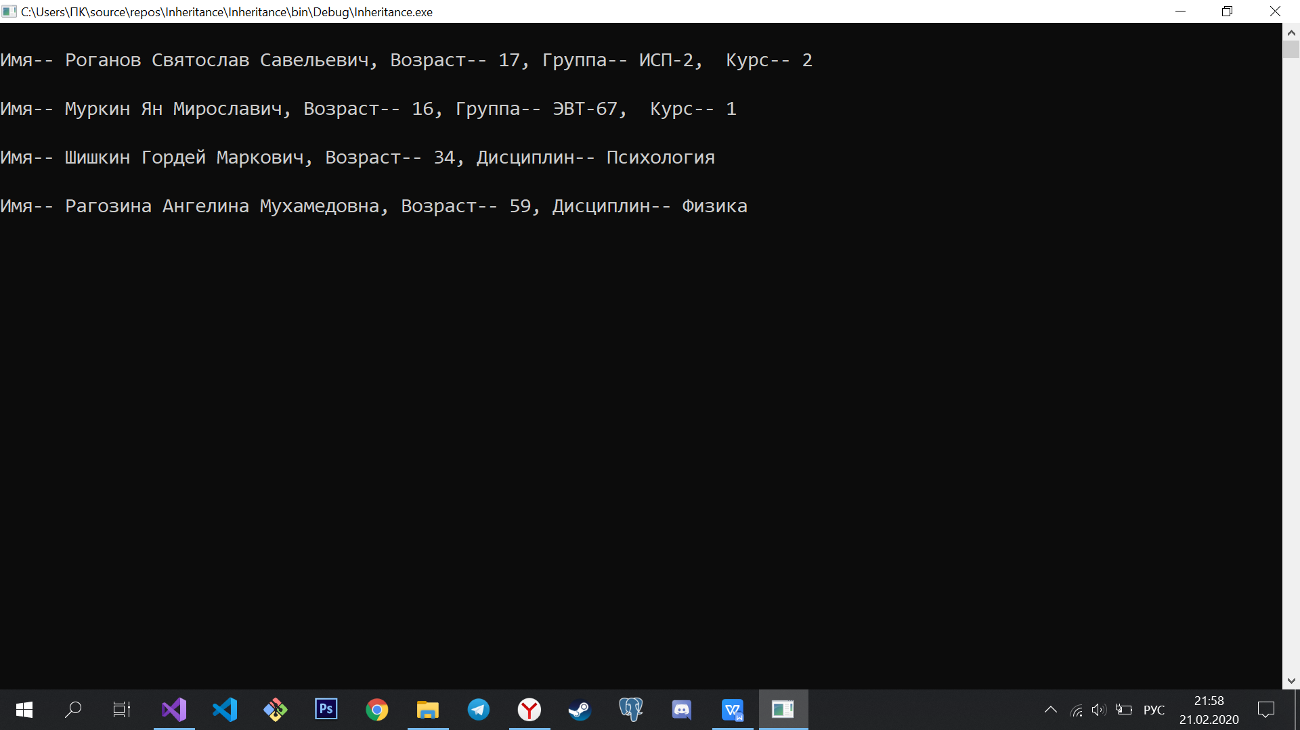

Снимок 1